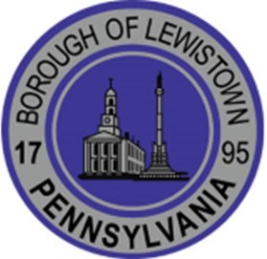
Borough of Lewistown
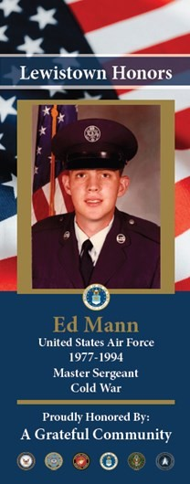
MILITARY BANNER PROGRAM
The Borough of Lewistown is honored to be home of men and women who are serving or have served and defended our great nation.

APPLICATION
How to Order:
- Completed order form
- Photograph of the service person in military uniform (if available)
- Payment by cash, check, or money order in the amount of $90 *
*This includes a double sided banner, mounting hardware, and installation
Checks –made payable to Borough of Lewistown
Applications received and approved prior to Oct 15th will be hung before Veteran’s Day of that year. Applications received after Oct. 15th will be displayed by Veteran's Day the following year.
Name: Address:
Phone: Email:
MILITARY HONOREE INFORMATION

Full Name:
*Spelling of the Honoree’s name will be taken directly from this application. Rank: BRANCH OF SERVICE:
□ ARMY □ MARINE CORPS □ NAVY
□ AIR FORCE □ COAST GUARD □ SPACE FORCE YEARS SERVED: (example 1972-1976)
SPECIAL INFO: (WIA, KIA, POW, ETC)
MEDALS: (PURPLE HEART, SILVER STAR, ETC)
PROUDLY HONORED BY: (if left blank– banner will say “ A Grateful Community)

Send form & payment to: Borough of Lewistown
Attention: Military Banner Program 2 East 3rd Street
Lewistown, PA 17044

Questions? Email boroinfo@lewistownborough.com

